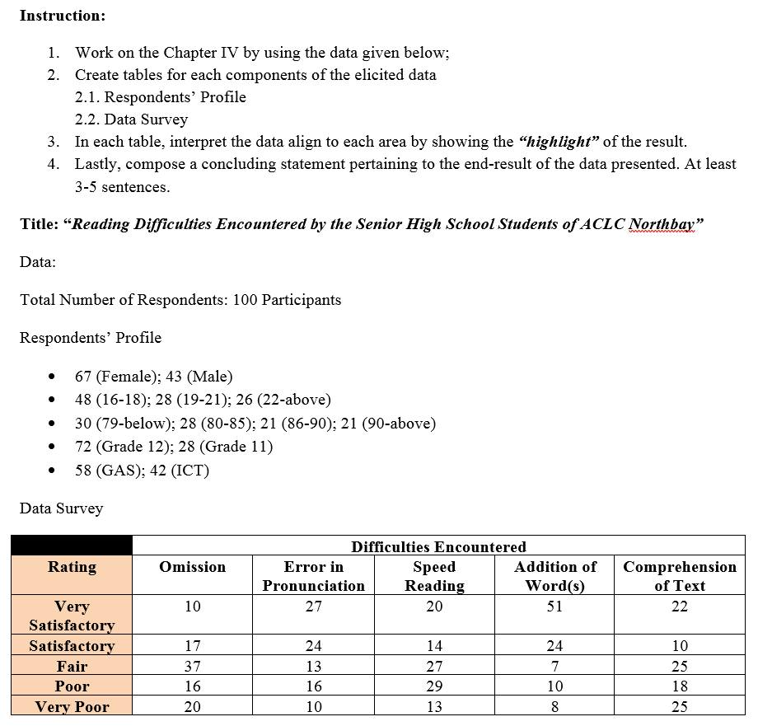
Chapter I
Introduction and Its Background
Introduction
We Filipinos love comics, manga, novels, etc. because of that some of us love to read especially us gen z, because of the trending manga and novels but did you know that as of December 3, 2019, according to Philstar global, Manila the Philippines Among 79 participating countries and Economies, the Philippines scored the lowest in reading comprehension in the 2018 Programme for International Student Assessment (PISA),
this is one of the reasons why people on social media or other platforms tend to be misinformed about what's happening around the world, especially now that the world is recovering from the pandemic. One of the affected people is the students as reported by the Philippines Statistics Authority(PSA)-In the 2010 Census of Population and Housing (2010 CPH),

The highest educational attainment was asked for persons aged 5, years old and over. The household population in this age bracket was recorded at 81.9 million, comprising 88.9 % of the total household population in the country.
Of the total household population aged five years and over, 19.1 percent had finished most high school, nonetheless, it’s important for students to be able to understand and comprehend what they are reading.
Objective
this study's aim is reading difficulties encountered by the senior high school students of ACLC north bay

- to make a word more readable

- to guide the students' habits of reading

Statement of the Problem
1. How can we make a readable text/font?

2. What makes a student read?

3. How can we solve the comprehension problem

Conceptual Framework


This flow was designed to further understand the variables and resources in sequence to simulate the possible outcomes that may predict and encounter in the progression of the study.
OUTPUT
- Effectiveness of reading

- Learning how to read different kinds of difficult book
.
- INPUT
.the importance of the text/fonts that we gonna read

- use of reading various books/articles

- numerous studies about reading in different fonts
.

Hypothesis
1. Reading various things like articles, newspapers, etc can improve your reading skills.
2. changing fonts of what your reading can improve your reading speed
Scope and Limitations
This study will help the students of aclc northbay how to read/comprehend what they want to read and at the same time teach them different kinds of techniques to improve their reading skills.

Significance of the Study
This research study was constructed with its aim to provide genuine pivotal information and further understanding that can help them in analyzing, comprehending, and disseminating accurate information that can help benefactors. Benefiting the study are the various sectors as follows:
The Students. This will help them in compromising meaningful ideas that can contribute to the progression of their study.
The Future Researchers. It will serve as reference data in a variety of resources in the near future. It will be easier for them to promulgate a website/webpage considering their accessibility for their references.

Definition of Terms
Font-style- A typeface variation (normal, bold, italic, bold italic).

Chapter II
Review of the Related Literature
Local Literature
Reading difficulties is one of the problems of many countries such as the Philippines, as stated in Philstar global, the Philippines is ranked the lowest in terms of comprehension, Reading comprehension encompasses a variety of skills that can permeate all aspects of life. Having strong reading abilities can enable you to interpret and find meaning in all that you read, and when you continuously improve these skills, you can develop your ability to communicate effectively through writing. in this pandemic it seems many students who dropped out get encouraged by the Senior high school program, that's why good reading skills are a must. this is the list of things you need to do if you want to improve your comprehension and reading skills

1.Set aside time to read each day.
One of the most effective ways to build your skills is to practice. Developing your reading skills will ultimately take practice, and you can set aside 10 to 15 minutes each day to read. You can read news articles, fiction, magazine issues, or any kind of text, as long as you are taking the time to practice your reading skills.

2. Set reading goals.
You can set reading goals for yourself to help you develop a wider vocabulary, gain a deeper understanding of different texts and improve your ability to make connections between things you read and your own perspectives and ideas.
For example, you might set a goal to learn different vocabulary related to a central topic like business management, technology, or another subject that interests you. Then, you can find meanings to unfamiliar words that help build your vocabulary as you read. As you build your vocabulary to higher-level words and phrases, you can increase the difficulty level of the texts you read.

3. Preview the texts you read.
Previewing and scanning over texts can be another step toward improving your reading skills. You can apply this strategy by previewing titles, captions, headlines, and other text features to get an idea of what you are reading about. This can help you form central ideas about the text before you begin reading it.

4. Determine the purpose.
As you read through different texts, practice determining the purpose. Think about why various texts were written and what meanings or themes can be understood from a text. Additionally, you might identify the purpose that you are reading for, such as to find information, follow instructions in a manual, or enjoy a story. Knowing your purpose for reading a text can help you look for key ideas and details that support your purpose.

5. Apply key reading strategies.
As you read different texts, you can apply several key strategies to help you increase your comprehension. For instance, when previewing a text, you might identify the text structure as informational, persuasive, or instructional. You might also determine key elements of different texts like the central themes, problems, and solutions or comparative ideas presented in what you read. Using strategies like identifying text features, determining the purpose, and taking notes can all work to help you improve your reading skills.

6. Take notes while you read.
Another highly effective method for improving your reading skills is to take notes while you read. For instance, you might take notes while reading a fiction novel to gain a deeper understanding of the author's choice of language, or you might write down new vocabulary while reading a science journal. Effective note-taking can prompt you to ask questions about and make connections to what you read.
Similarly, creating visual representations like charts, tables or diagrams can clarify themes and ideas and can help you form inferences from your reading. Note-taking can be highly beneficial for comprehension exercises like summarizing, too.

7. Apply what you read by summarizing.
Summarizing what you read can also improve your reading skills. Summarizing forces you to remember specific details and central topics about what you read in your own words and through your own unique perspective. You might try verbally summarizing what you read by sharing information with a friend or writing a short summary to help you retain and comprehend what you read.
As you develop your reading skills, your communication and overall ability to interact with others and perform in your career can develop as well.
Foreign Literature
In the Philippines fonts are most used for editing text, using for texting, and for chatting, Multiple studies, like the one conducted by Sarah Morrison and Jan Noyes of the University of Bristol, have found that Times New Roman is the best typeface for reading any document. Readers speed through material faster thanks to its simple letters. Whether in print or on your computer screen, Times New Roman fonts are both easy on the eyes and familiar. Sure, you've seen Times New Roman a million times, in document after document, but why is familiarity connected to speed? Times New Roman isn't familiar because you've seen it over and over again. In fact, it's because we recognize its letter shapes and associate them with handwritten letters. Serif fonts, which are defined by Purdue OWL as feet added to a font, are considered by many to be the easiest fonts for us to read. Because they include tails, flourishes, and curves similar to the way we write by hand, they trick us into thinking they're more handwriting than type.
Local Studies
Some people are having a hard time reading with gadgets like laptops, cellphones, or computers Focusing on a screen, whether it’s your work screen or your post-work FUN SCREEN, can feel like it’s draining the life force right out of you, and making it impossible to focus on anything longer than 280 characters But a new tool, a font called “Bionic Reading,” claims to help readers—particular those with attention issues—focus on an absorbing text. The font renders “the most concise parts of words” in bold, which the font’s creators claim will “guide the eye over the text” and help the brain remember “previously learned words more quickly.” Bionic reading is a new method facilitating the reading process by guiding the eyes through text with artificial fixation points as a result, the reader is only focusing on the highlighted initial letters and lets the brain center complete the word. in a digital world dominated by shallow forms of reading, bionic reading also encourage a more in-depth reading and understanding of written content
Foreign Studies
Reading comprehension is a complex cognitive process involving many human brain activities. Plenty of works have studied the Understanding one thing is a must before giving your opinion that's why we are making a research on something that we don't understand or we lack knowledge about, according to Cornell University-reading patterns and attention allocation mechanisms in the reading process. However, little is known about what happens in the human brain during reading comprehension and how we can utilize this information as implicit feedback to facilitate information acquisition performance. With the advances in brain imaging techniques such as EEG, it is possible to collect high-precision brain signals in almost real-time. With neuroimaging techniques, we carefully design a lab-based user study to investigate brain activities during reading comprehension. Our findings show that neural responses vary with different types of content, i.e., content that can satisfy users' information needs and content that cannot. We suggest that various cognitive activities, e.g., cognitive loading, semantic-thematic understanding, and inferential processing, at the micro-time scale during reading comprehension underpin these neural responses. Inspired by these detectable differences in cognitive activities, we construct supervised learning models based on EEG features for two reading comprehension tasks: answer sentence classification and answer extraction. Results show that it is feasible to improve their performance with brain signals. These findings imply that brain signals are valuable feedback for enhancing human-computer interactions during reading comprehension.

Chapter III
Research Methodology
Research Design
The researchers employed a quantitative research design to collect all the data in the survey, as well as the information needed. All respondents in the survey were used and subjected to the descriptive approach, which used questionnaires as an instrument of the study.
Locale of the Study
The study was conducted by OECD, PISA 2018 Database
Population and Sampling
The OECD Programme for International Student Assessment (PISA) examines what students know in reading, mathematics and science, and what they can do with what they know. It provides the most comprehensive and rigorous international assessment of student learning outcomes to date.

Research Instrument
In this study, researchers use a questionnaires question one by one they, give students subjective questionnaires like examples
all students will take 3 questionnaires on the subjects of Reading, Mathematics, and English.
Data Gathering Procedure
PISA 2018 was the seventh round of the international assessment since the programme was launched in 2000. Every PISA test assesses students’ knowledge and skills in reading, mathematics and science; each assessment focuses on one of these subjects and provides a summary assessment of the other two. In 2018, the focus was on reading in a digital environment; but the design of the assessment also made it possible to measure trends in reading literacy over the past two decades. PISA 2018 defined reading literacy as understanding, using, evaluating, reflecting on and engaging with texts in order to achieve one’s goals, to develop one’s knowledge and potential, and to participate in society. PISA 2018 also collected extensive data on students’ attitudes and well-being.

Data Analysis Procedure
Level 6 Above 698.32 score points Level 5 From 625.61 to less than 698.32 score points Level 4 From 552.89 to less than 625.61 score points Level 3 From 480.18 to less than 552.89 score points Level 2 From 407.47 to less than 480.18 score points Level 1a From 334.75 to less than 407.47 score points Level 1b From 262.04 to less than 334.75 score points Level 1c From 189.33 to less than 262.04 score points Below level 1c Less than 189.33 score points

Chapter IV
Presentation, Analysis and Interpretation

This chapter presented how the quantitative data was acquired, as well as how it was analyzed and interpreted. The respondents’ responses to the completed questionnaires were statistically analyzed using the research instrument of the study. This study started by presenting the data clearly and correctly.
Respondents’ Profile
The age of the participants ranged from 15 years old and above
or grade 7 and higher
The 15-year-olds in the PISA sample must also have been enrolled in an educational institution at grade 7 or higher. All such students were eligible to sit the PISA assessment, regardless of the type of educational establishment in which they were enrolled and whether they were enrolled in full-time or part-time education.
Table 1: Distribution of the Respondents’ Profile in terms of Age.
In the above table, this result has shown that among the respondents, there were thirteen (13) with twenty-six percent (26%) of them from the age group of fifteen to sixteen (15-16). While there were twelve (12) with twenty-four (24%) of them belonging to the age group of eighteen to twenty (18-20). Lastly, from the age group of twenty (20) and above, there were twenty-five (25) or fifty percent (50%).
This means that the greatest number of respondents who answered the survey came from the group aged twenty-one (21) and above.
Table 2: Distribution of the Respondents’ Profile in terms of Social Status.
Age | SOCIAL STATUS | S.D|Mean score | Subjects
15 | Middle income household | 80|340 | Reading
15 | Middle income household | 77|353 | Mathematics
15 | Middle income household | 75|357 | Science
in the table above, as you can see the Philippines ranked second to lowest or lowest in a test that Pisa gives if you look at the age of the student participant, you can see that their scores are ranging from 75-80 which is the lowest of all countries that participated in Pisa
this means that the students in the Philippines are lowest in terms of some subjects like math,science, and Reading
Ps: if cant understand the data above you can look at data analysis section to understand it further
Conclusion:
In conclusion, students in the Philippines need improvements in terms of subjects shown above the table, many arguments and debates came when the Pisa release the data that the Philippines is the lowest or second to the lowest in terms of math, science, and reading, many teachers get agitated because their efforts seem wasted some agree and many are suspicious of the data Pisa shows, but at the end of the day, the students itself will be the one to show if its true or not.

<above contents are all done for revision, START EDITING CONTENTS FROM HERE, check the numbering of the table as follows from the table above, no longer editions and revisions needed for chapter 5, just include researchers’ signature on each curriculum vitae. Lastly, check the spacing and distance of each component. This is almost ready for hardbound, advance congratulations!>
Table 4: Is the webpage interactive?
ANSWER | FREQUENCY (f) | PERCENTAGE (p)
Yes | 35 | 70
No | 15 | 30
Total | 50 | 100
In the above table, this result shown that among the respondents, there were thirty- five (35) with sixty-two (70%) answered Yes. While, there were fifteen (15) with thirty (30%) answered No.
This means that the greatest number of respondents from the survey came from the participants who answered “Yes”.
Table 5: Is the webpage easy to access and to navigate?
ANSWER | FREQUENCY (f) | PERCENTAGE (p)
Yes | 40 | 80
No | 10 | 20
Total | 50 | 100
In the above table, this result shown that among the respondents, there were fourty (40) with eighty (80%) answered Yes. While, there were fifteen (15) with thirty (30%) answered No.
This means that the greatest number of respondents from the survey came from the participants who answered “Yes”.
Table 6: Do you consider our webpage as a great tool in attaining your wants?
ANSWER | FREQUENCY (f) | PERCENTAGE (p)
Yes | 26 | 52
No | 24 | 48
Total | 50 | 100
In the above table, this result shown that among the respondents, there were twenty-six (26) with fifty-two (52%) answered Yes. While, there twenty-four (24) with fourty-eight (48%) answered No.
This means that the greatest number of respondents from the survey came from the participants who answered “Yes”.
TABLE 7: Does this webpage help you in seeking the informations you needed about the store?
ANSWER | FREQUENCY (f) | PERCENTAGE (p)
Yes | 37 | 74
No | 13 | 26
Total | 50 | 100
In the above table, this result shown that among the respondents, there were thirty-seven (37) with seventy-four (74%) answered Yes. While, there thirteen (13) with twenty-six (26%) answered No.
This means that the greatest number of respondents from the survey came from the participants who answered “Yes”.
Table 8: Is the design of the webpage aesthetically unique and pleasing?
ANSWER | FREQUENCY (f) | PERCENTAGE (p)
Yes | 25 | 50
No | 25 | 50
Total | 50 | 100
In the above table, this result shown that among the respondents, there were twenty-five (25) with fifty (50%) answered Yes. While, there twenty-five (25) with twenty-five (25%) answered No.
This means that the greatest number of respondents from the survey came from the participants who answered both of the given choices.
Table 9: Is the webpage really effective in catering the inquries of the users?
ANSWER | FREQUENCY (f) | PERCENTAGE (p)
Yes | 40 | 80
No | 10 | 20
Total | 50 | 100

In the above table, this result shown that among the respondents, there were fourty (40) with eighty (80%) answered Yes. While, there ten (10) with twenty (20%) answered No.
This means that the greatest number of respondents from the survey came from the participants who answered “Yes”.
Table 10: Do you think people would support the shop by the use of a webpage in promoting the business?
ANSWER | FREQUENCY (f) | PERCENTAGE (p)
Yes | 35 | 70
No | 15 | 30
Total | 50 | 100

In the above table, this result shown that among the respondents, there were thirty-five (35) with seventy (70%) answered Yes. While, there fifteen (15) with thirty (30%) answered No.
This means that the greatest number of respondents from the survey came from the participants who answered “Yes”.

Chapter V
Summary of Findings, Conclusions and Recommendations
This chapter presented a summary of the findings, conclusions, and recommendations concerning the study in further development.
Summary of Findings
This study focused on providing good quality and easy-to-use webpage for Fairyloops.Ph to allure more customers and make the customer service way better.
Finding 1: The study showed that twenty-five (25) of the respondents range their age between 21 and above.
Findings 2: In the study, the table showed the majority of the respondents were mostly students.
Findings 3: The study showed that most of the respondents answered that they found their preferred factors included in the Web Page.
Findings 4: The study showed that most of the respondents highly agreed that the factors they are looking for are placed on the Web Page.
Findings 5: The table showed that the majority of the respondents believe that the information so provided by the webpage is clear.
Findings 6: The study showed that most of the respondents think that the webpage is interactive enough to communicate.
Findings 7: The study showed that the majority of the respondents agreed that the webpage has easy accessibility and navigation.
Findings 8: The study showed that most of the respondents considered the webpage as a great tool in attaining their wants.
Findings 9: The study showed that the majority of the respondents acknowledge the webpage in helping them to seek information they needed following the store.
Findings 10: The study showed half of the respondents perceive the design of the webpage as aesthetically pleasing and unique.
Findings 11: The study showed that the majority of the respondents appreciate the effectiveness of the webpage in catering to the inquiries of the users.
Findings 12: The study showed that most of the respondents conceive that the people would support the shop by the use of a webpage in promoting the business.
Conclusions
The researchers created and provided a webpage for the customers of Fairyloops.Ph, they made it for them to experience an easy and creative way of purchasing products and services within the parameter of the webpage. The study showed that they positively found their preferred factors placed in the webpage because of the traits offered by it. Also, based on the findings conducted the information offered by the webpage is clearly stated and explained. Other than the factors considered, it also showed that the webpage is interactive enough to communicate with the possible leads to meet the concerns and satisfactions they are aiming for. Easy accessibility and navigations are the factors that a good webpage must contain to attract customers to purchase an item. It is a great tool in attaining their wants because it makes their transactions and deals way easier and faster. The aesthetically pleasing and unique design of a webpage allure the curiosity of a possible lead to purchase products. An effective webpage must cater to the possible inquiries of the user that can be used in improving the following concerns. Making a webpage can promote the business to a larger quantity of market which can lead to the support of the mass market.
Recommendation
The researchers recommended on the technical aspects of a webpage must contain the factors including the user friendly, interactive, easy to access, and navigate to achieve a good quality webpage that can allure many possible leads to visit and support the business. Implementing clear and organized information within the parameter of a webpage can cure the curiosity of the consumer concerning the products and services offered by the business itself. Particularly, promoting the business with the use of a webpage can fascinate a larger quantity of consumers which can help in boosting success on its own since many people can have the access to inquire about their concerns with the business and the suggestions that they can offer for the betterment of the business.
Bibliography
NA (2020) “The purpose of a website.” NA
Palaganas, J. (2017) “Review of Related Literature.” NA
https://www.academia.edu/32235928/Chapter_2_REVIEW_OF_RELATED_LITERATURE_AND_STUDIES
Talaue, G. (2017) “Internal Journal of Online Marketing.” Saudi, Arabia https://www.igi-global.com/article/assessment-of-e-business-mode-of-selected-private-universities-in-the-philippines-and-pakistan/188850
Hernández, B. Jiménez, J. M. Martín, J. (2017) “Key website factors in e-business strategy.”
Volume 29: Issue 5, Pages 362-371, https://doi.org/10.1016/j.ijinfomgt.2008.12.006.
Vaughan, L. (2004) “Exploring website features for business information” Volume 61: Issue 3
https://akjournals.com/view/journals/11192/61/3/article-p467.xml
Lee, Y. Kozar, K (2006) “Investigating the effect of website quality on e-business success: An analytic hierarchy process (AHP) approach.” Volume 42: Issue 3,
https://doi.org/10.1016/j.dss.2005.11.005.
Cerdan, A. et al., Acosta, P. (2005) “Examining e-business impact on firm performance through website analysis” https://www.inderscienceonline.com/doi/abs/10.1504/IJEB.2005.008537
Appendices
TABLE 1: Distribution of the profile variable of the respondents in terms of age
15 – 17 years old
18 – 20 years old
21 and above
TABLE 2: Social Status of the Respondents
Student
Working
Non - Working

TABLE 3: DATA SURVEY
Q1. What are the factors you consider in visiting our webpage?
It has a great theme Very accessible
Easy to navigate All of the above
Q2. Are the factors you are looking for provided in our webpage?
Yes
No
Q3. Is the informations provided by our webpage clear?
Yes
No
Q4. Is the webpage interactive?
Yes
No
Q5. Is the webpage easy to access and to navigate?
Yes
No
Q6. Do you consider our webpage as a great tool in attaining your wants?
Yes
No
Q7. Does this webpage help you in seeking the informations you needed about the store?
Yes No
Q8. Is the design of the webpage aesthetically unique and pleasing?
Yes No
Q9.Is the webpage really effective in catering the inquries of the users?
Yes No
Q10.Do you think people would support the shop by the use of a webpage in promoting the business?
Yes No

Source Code

"HOME"

<html>
<head>
<title>Home</title>
</head>
<body background="green.jpg">
<font color=black>
<h1 align =center>Fairyloops.Ph</h1>
</font>
<hr>
<center>
<imgsrc="logo.jpg" width="300" height="300">
<table border=3 bgcolor=white width=50%>
<th><a href="Home.html">HOME</a></th>
<th><a href="Products.html">PRODUCTS</a></th>
<th><a href="About us.html">ABOUT US</a></th>
<th><a href="Contacts.html">CONTACTS</a></th>
</table>
</center>
<hr>
<center>
<table border=5 bgcolor=white cellpadding=10 width=75%
<tf>
<marquee scrollamount="20" direction="left">
<imgsrc="sunflower w tulips.jpg" height=200>
<imgsrc="sunflower w roses.jpg" height=200>
<imgsrc="crocheted flower.jpg" height=200>
<imgsrc="butterfly top.jpg" height=200>
<imgsrc="brown butterfly top.jpg" height=200>
</marquee>
</td>
</table>
</center>

</body>
</html>

"PRODUCTS"

<html>
<head>
<title>PRODUCTS</title>
</head>
<body background="green.jpg">
<font color=black>
<h1 align =center>PRODUCTS</h1>
</font>
<hr>
<center>
|<table border=3 bgcolor=white width=50%>
<th><a href="Home.html">HOME</a></th>
<th><a href="About Us.html">ABOUT US</a></th>
<th><a href="Contacts.html">CONTACTS</a></th>

</table>
</center>
</hr>
<font color=black size=5>
<h1>PRODUCTS OFFERED</h1>
<ul>
<li><h4>Sunflower with Tulips - 200</h4>
<p>(Sunflower with tulips) Blend with a mixture of a rich color of a pink and yellow.
he beautiful images portrays its good quality of an accessory.<br>
<br>It benefits not only as a good display, but also a plus point in making your day extra joyful just by looking at it.<br>
<li><h4>Sunflower with Roses - 200</h4>
<p>(Sunflower w roses) A handcraft accessory designed to capture the attention of our beloved customers.<br>
<br/>A mixture of a good quality of fabrics, which is best to give to your loved ones.</p>
<li><h4>Crocheted Flower - 200</h4>
<p>(Crocheted Flower) Our most beautiful product, available in a different variety of design to help brighten up anybody's surroundings. <br>
<br/>The rich mixture of very catchy colors of white, pink, blue, green, purple, and yellow.</p>
<li><h4>Butterfly Top - 300</h4>
<p>(Butterfly Top) Comfortable, classy, fitted, aesthetic, and trendy top will quickly become one of your favorites. With its natural design and gorgeous variety of color.<br>
<br>- Adjustable - Standard Fit <br>- Fits true to size <br>- 100% Made from yarn - Trendy <br>- Could be use as an alternative gift <br>- 100% Made from yarn <br>- Perfect for giving on to your loved ones
<br>- Variety of your preferred choices of colors
<br>- 100% Made from Yarn</p>
<li><h4>Brown Butterfly - 280</h4>
<p>(Brown Butterfly Top) A piece of cloth apparel designed to perfectly fits the trendy products nowadays. Designed with its intention to provide a perfect outfits for you<br>
<br>- Standard Fit <br>- Fits true to size - 100% Made from yarn</p>
</ul>
</body>
</html>

"ABOUT US"

<html>

<head>
<title>ABOUT US</title>
</head>
<body background="green.jpg">
<font color=black>
<h1 align =center>ABOUT US</h1>
</font>
<hr>
<center>
<table border=3 bgcolor=white width=50%>
<th><a href="Home.html">HOME</a></th>
<th><a href="Products.html">PRODUCTS</a></th>
<th><a href="Contacts.html">CONTACTS</a></th>
</table>
</center>
</hr>
<font color=Black>

<marquee="scroll down"><h1>Fairyloops.Ph is a handcrafting business that promotes fashionable cloth apparels and accessories in a sustainable and affordable prices. It is owned and runned by a teen shs student who dreams of becoming successful in this field of area.
We encouraged customers to avail pieces that is good for our environment in which way our product excels. Innovation and simplicity makes us happy; Our goal is to satisfy the wants and needs of our beloved customers and by that we gratefully made this website that can easily help them maneuver in their own taste. We're very much excited to help you on your journey!</h1></marquee>
</font>
</body>
</html>

"CONTACTS"

<html>
<head>
<title>CONTACTS</title>
</head>
<body background="green.jpg">
<font color=black>

<h1 align =center>CONTACTS</h1>
</font>
<hr>
<center>
<table border=3 bgcolor=white width=50%>
<th><a href="Home.html">HOME</a></th>
<th><a href="Products.html">PRODUCTS</a></th>
<th><a href="About Us.html">ABOUT US</a></th>
</table>
</center>
</hr>
<font color=black>
<h1>CONTACTS</h1>
<ul>
<li>Address: 1245 Lualhati St. Tondo Manila
<li>Contact #: 094929132835
<li>Instagram: MadebyCorrine
<li>Facebook: Fairyloops
<li>Twitter: _madebycorrine
</ul>

</font>
</body></html>
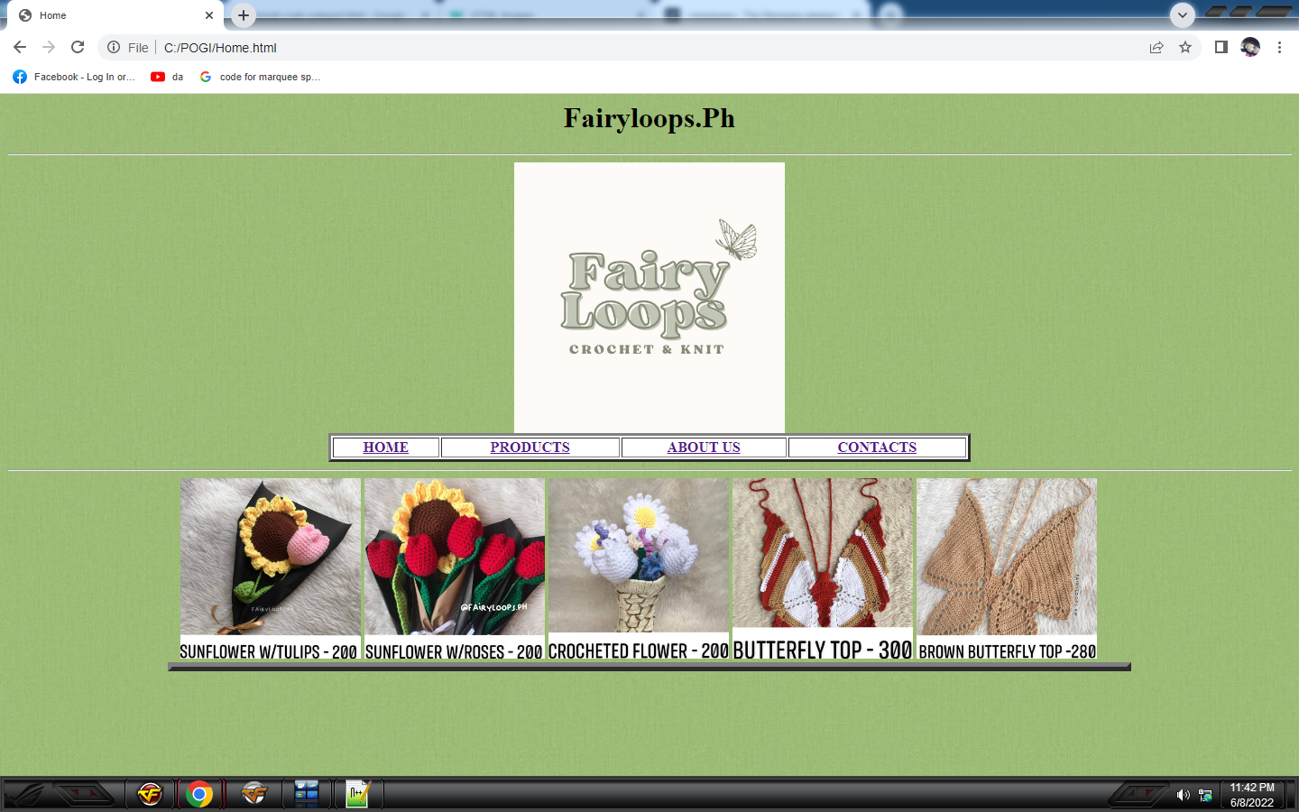
Proof of Survey Screenshot of Webpage
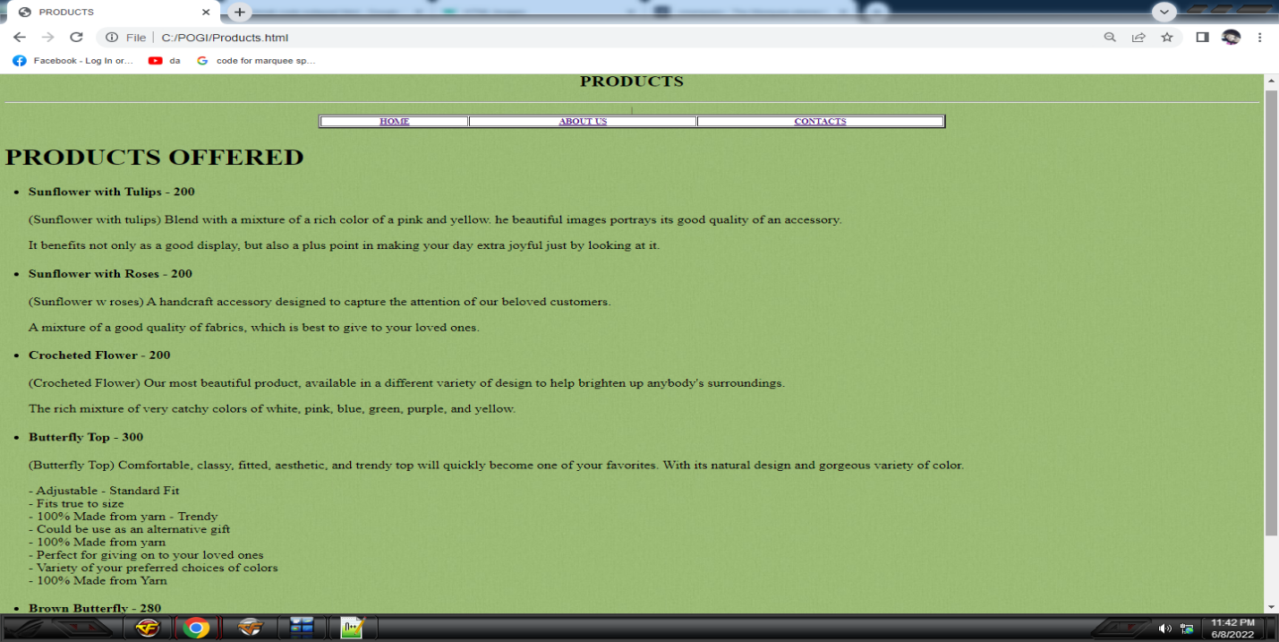
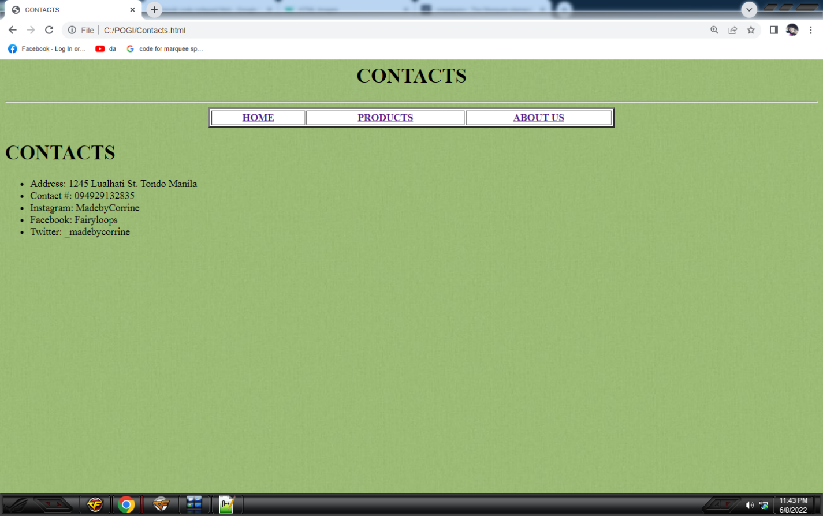
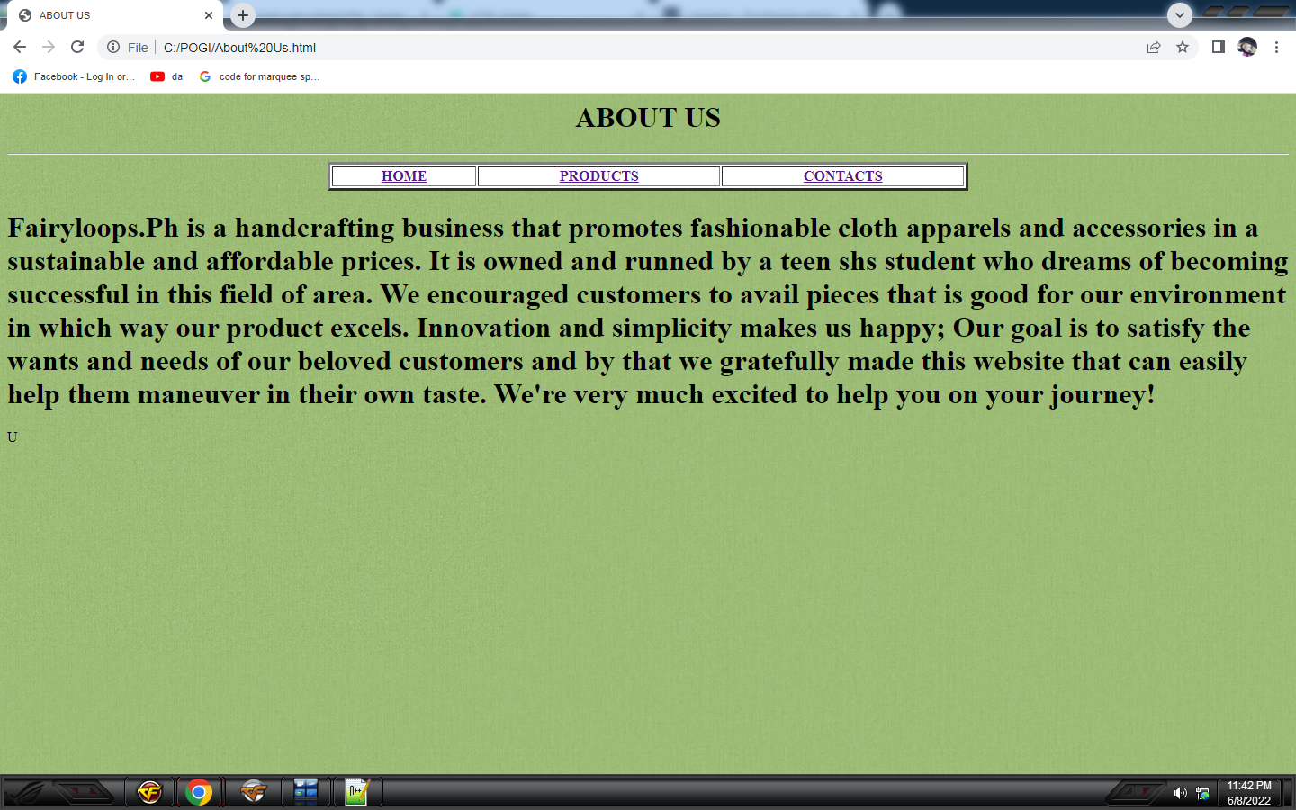

Curriculum Vitae/ Resume

PERSONAL DATA
Name: Renerose Flores
Sex: Female
Date of Birth: September 12, 2004
Civil Status: Single
Address: 1253 Tagumpay St. Tondo, Manila
Name of Father: Allan Belino
Name of Mother: Vevilyn F. Barros

EDUCATIONAL ATTAINMENT
Level School Attended Year Attended
ElementaryMagat Salamat Elementary School 2009 – 2015
Junior High SchoolLakandula High School 2016 – 2020
Senior High School AMA Computer Learning Center Northbay 2020 – 2022
Strand TVL- ICT (Information and Technology


PERSONAL DATA
Name: Kurtnie Love D. Delos Santos
Sex: Female
Date of Birth: May 23, 2003
Civil Status: Single
Address: 1384 R.A Reyes St. Tondo Manila
Name of Father: Randolf A. Delos Santos
Name of Mother: Joan D. Delos Santos
EDUCATIONAL ATTAINMENT
Level School Attended Year Attended
ElementaryManuel L. Quezon Elementary School 2009 – 2015
Junior High SchoolDr. Juan G. Nolasco High School2016 – 2020
Senior High School AMA Computer Learning Center Northbay 2020 – 2022
Strand TVL- ICT (Information and Technology


PERSONAL DATA
Name: Piolo Raphael D. Balboa
Sex: Male
Date of Birth: June 13, 2003
Civil Status: Single
Address: 385-A Pacheco LacsonstTondo,Manila
Name of Father: Manolito A. Balboa
Name of Mother: Edna D.Balboa
EDUCATIONAL ATTAINMENT
Level School Attended Year Attended
Elementary West Manila Christian School 2009 – 2015
Junior High SchoolDr Juan G Nolasco High School2016 – 2020
Senior High School AMA Computer Learning Center Northbay2020 – 2022
Strand TVL- ICT (Information and Technology


PERSONAL DATA
Name: RubeinLae F. Hayag
Sex: Female
Date of Birth: February 15, 2004
Civil Status: Single
Address: 238 Mel-Alcalde St. Tondo, Manila
Name of Father: Ruben M. Hayag
Name of Mother: Maria M. Feliciano
EDUCATIONAL ATTAINMENT
Level School Attended Year Attended
ElementaryTeodoro R. Yangco Elementary School 2010 – 2016
Junior High SchoolDr. Juan G. Nolasco High School2016 – 2020
Senior High School AMA Computer Learning Center Northbay 2020 – 2022
Strand TVL- ICT (Information and Technology


PERSONAL DATA
Name: Jan Dreb B. Dela Cruz
Sex: Male
Date of Birth: May 21, 2004
Civil Status: Single
Address: 424 DP Ortega St. Tondo, Manila
Name of Father: Federico B. Dela Cruz Jr.
Name of Mother: Maria Victoria B. Dela Cruz
EDUCATIONAL ATTAINMENT
Level School Attended Year Attended
ElementaryMagat Salamat Elementary School 2009 – 2015
Junior High SchoolFlorentino Torres High School2016 – 2020
Senior High School AMA Computer Learning Center Northbay2020 – 2022
Strand TVL- ICT (Information and Technology

